**1.Implement and demonstrate the FIND-S algorithm for finding the most specific hypothesis based on a given set of training data samples.**

def find_s_algorithm(training_data):

# Get the number of attributes

num_attributes = len(training_data[0]) - 1 # Last column is the target

# Step 1: Initialize hypothesis with most specific values

hypothesis = ['Ø'] * num_attributes

# Step 2: Iterate through training data

for example in training_data:

attributes, label = example[:-1], example[-1]

# Only consider positive examples

if label.lower() == 'yes':

for i in range(num_attributes):

if hypothesis[i] == 'Ø':

hypothesis[i] = attributes[i]

elif hypothesis[i] != attributes[i]:

hypothesis[i] = '?'

return hypothesis

training_data = [

['Sunny', 'Warm', 'Normal', 'Strong', 'Warm', 'Same', 'Yes'],

['Sunny', 'Warm', 'High', 'Strong', 'Warm', 'Same', 'Yes'],

['Rainy', 'Cold', 'High', 'Strong', 'Warm', 'Change', 'No'],

['Sunny', 'Warm', 'High', 'Strong', 'Cool', 'Change', 'Yes']

]

hypothesis = find_s_algorithm(training_data)

print("Most specific hypothesis:", hypothesis)

**Output:**



**2. For a given set of training data examples stored in a .CSV file, implement and demonstrate the Candidate-Elimination algorithm in python to output a description of the set of all hypotheses consistent with the training examples**

import pandas as pd

def load_data(filename):

data = pd.read_csv(filename)

attributes = data.columns[:-1]

examples = data.values.tolist()

return attributes, examples

def more_general(h1, h2):

return all((x == '?' or x == y) for x, y in zip(h1, h2))

def candidate_elimination(examples):

num_attributes = len(examples[0]) - 1

# Initialize S and G

S = ['Ø'] * num_attributes

G = [['?'] * num_attributes]

for example in examples:

x, y = example[:-1], example[-1].lower()

if y == 'yes':

# Remove any g in G inconsistent with x

G = [g for g in G if more_general(g, x)]

# Update S to be more general only where needed

for i in range(num_attributes):

if S[i] == 'Ø':

S[i] = x[i]

elif S[i] != x[i]:

S[i] = '?'

elif y == 'no':

# Remove any s in S consistent with x

if more_general(S, x):

S = ['Ø'] * num_attributes

new_G = []

for g in G:

if more_general(g, x):

for i in range(num_attributes):

if g[i] == '?':

for val in set(e[i] for e in examples if e[-1].lower() == 'yes'):

if val != x[i]:

new_hypothesis = g.copy()

new_hypothesis[i] = val

if more_general(new_hypothesis, S):

new_G.append(new_hypothesis)

G = new_G

return S, G

filename = "training_data.csv"

attributes, data = load_data(filename)

S_final, G_final = candidate_elimination(data)

print("Final Specific Hypothesis (S):")

print(S_final)

print("\nFinal General Hypotheses (G):")

for g in G_final:

print(g)

**Output:**

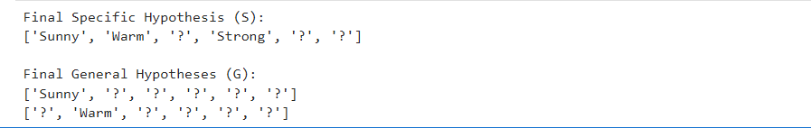

**3. Demonstrate the working of the decision tree based ID3 algorithm. Use an appropriate  
data set for building the decision tree and apply this knowledge to classify  
a new sample.**

import pandas as pd

from sklearn.tree import DecisionTreeClassifier

from sklearn.preprocessing import LabelEncoder

# Step 1: Create the dataset

data = {

'Outlook': ['Sunny','Sunny','Overcast','Rain','Rain','Rain','Overcast',

'Sunny','Sunny','Rain','Sunny','Overcast','Overcast','Rain'],

'Temperature': ['Hot','Hot','Hot','Mild','Cool','Cool','Cool','Mild',

'Cool','Mild','Mild','Mild','Hot','Mild'],

'Humidity': ['High','High','High','High','Normal','Normal','Normal',

'High','Normal','Normal','Normal','High','Normal','High'],

'Wind': ['Weak','Strong','Weak','Weak','Weak','Strong','Strong','Weak',

'Weak','Weak','Strong','Strong','Weak','Strong'],

'PlayTennis': ['No','No','Yes','Yes','Yes','No','Yes','No',

'Yes','Yes','Yes','Yes','Yes','No']

}

df = pd.DataFrame(data)

# Step 2: Encode the categorical features

le_dict = {}

for col in df.columns:

le = LabelEncoder()

df[col] = le.fit_transform(df[col])

le_dict[col] = le

# Step 3: Split into features and target

X = df.drop('PlayTennis', axis=1)

y = df['PlayTennis']

# Step 4: Train Decision Tree using ID3 (entropy)

model = DecisionTreeClassifier(criterion='entropy')

model.fit(X, y)

# Step 5: Show internal decision rules as text

from sklearn.tree import export_text

tree_rules = export_text(model, feature_names=list(X.columns))

print("ID3 Decision Tree Rules:\n")

print(tree_rules)

sample = pd.DataFrame([[

le_dict['Outlook'].transform(['Sunny'])[0],

le_dict['Temperature'].transform(['Cool'])[0],

le_dict['Humidity'].transform(['High'])[0],

le_dict['Wind'].transform(['Strong'])[0]

]], columns=X.columns)

prediction = model.predict(sample)

result = le_dict['PlayTennis'].inverse_transform(prediction)[0]

print(f"\nPrediction for sample ['Sunny', 'Cool', 'High', 'Strong']: {result}")

**Output:**

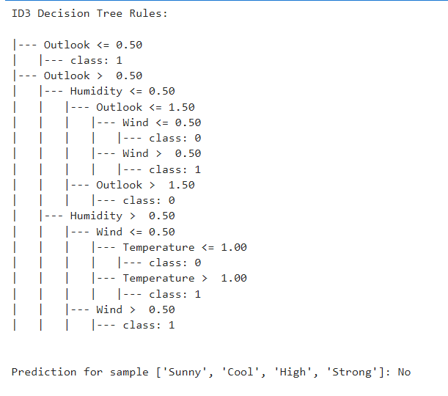

**4. Build an Artificial Neural Network by implementing the Backpropagation algorithm and test the same using appropriate data sets.**

import numpy as np

from sklearn.datasets import load_iris

from sklearn.model_selection import train_test_split

from sklearn.preprocessing import OneHotEncoder, StandardScaler

# Load and preprocess the Iris dataset

iris = load_iris()

X = iris.data

y = iris.target.reshape(-1, 1)

# One-hot encode the output

encoder = OneHotEncoder(sparse_output=False)

y_encoded = encoder.fit_transform(y)

# Normalize features

scaler = StandardScaler()

X_scaled = scaler.fit_transform(X)

# Train/test split

X_train, X_test, y_train, y_test = train_test_split(X_scaled, y_encoded, test_size=0.2, random_state=42)

# Define the neural network class

class NeuralNetwork:

def __init__(self, input_size, hidden_size, output_size, lr=0.1):

self.lr = lr

self.W1 = np.random.randn(input_size, hidden_size)

self.b1 = np.zeros((1, hidden_size))

self.W2 = np.random.randn(hidden_size, output_size)

self.b2 = np.zeros((1, output_size))

def sigmoid(self, x):

return 1 / (1 + np.exp(-x))

def sigmoid_derivative(self, x):

return x * (1 - x)

def forward(self, X):

self.z1 = np.dot(X, self.W1) + self.b1

self.a1 = self.sigmoid(self.z1)

self.z2 = np.dot(self.a1, self.W2) + self.b2

self.a2 = self.sigmoid(self.z2)

return self.a2

def backward(self, X, y, output):

error = y - output

d_output = error * self.sigmoid_derivative(output)

error_hidden = d_output.dot(self.W2.T)

d_hidden = error_hidden * self.sigmoid_derivative(self.a1)

# Update weights and biases

self.W2 += self.a1.T.dot(d_output) * self.lr

self.b2 += np.sum(d_output, axis=0, keepdims=True) * self.lr

self.W1 += X.T.dot(d_hidden) * self.lr

self.b1 += np.sum(d_hidden, axis=0, keepdims=True) * self.lr

def train(self, X, y, epochs=1000):

for epoch in range(epochs):

output = self.forward(X)

self.backward(X, y, output)

if epoch % 100 == 0:

loss = np.mean((y - output) ** 2)

print(f"Epoch {epoch} - Loss: {loss:.4f}")

def predict(self, X):

output = self.forward(X)

return np.argmax(output, axis=1)

# Initialize and train the model

nn = NeuralNetwork(input_size=4, hidden_size=6, output_size=3, lr=0.1)

nn.train(X_train, y_train, epochs=1000)

# Test the model

y_pred = nn.predict(X_test)

y_true = np.argmax(y_test, axis=1)

# Evaluate accuracy

accuracy = np.mean(y_pred == y_true)

print(f"\nTest Accuracy: {accuracy * 100:.2f}%")

**Output:**

